

ISLAMIC UNIVERSITY OF TECHNOLOGY (IUT)
ORGANISATION OF ISLAMIC COOPERATION (OIC)
Department of Computer Science and Engineering (CSE)

MID STATISTICS

Average Breakdown

Details
Question |  |  | Topic | Full Marks | Avg | Avg | % | %
1 | a |  | Binary to XS-5 Truth Table | 4 | 3.54 | 14.86 | 88.56 | 49.52
 | b |  | K-map Simplification | 16 | 7.52 |  | 46.98
 | c |  | 2 Level NAND Implementation | 7 | 2.84 |  | 40.56
 | d |  | Self Complementing Code | 3 | 0.96 |  | 31.92
2 | a | i | BCD Conversion | 4 | 3.90 | 18.14 | 97.46 | 60.48
 |  | ii | BCD Sum | 8 | 4.95 |  | 61.86
 |  | iii | Subtraction using 7's Complement | 10 | 5.08 |  | 50.85
 | b |  | Checksum Integrity | 5 | 2.28 |  | 45.59
 | c |  | BCD vs Binary Addition | 3 | 1.93 |  | 64.41
3 | a |  | Tabular Method Simplification | 15 | 12.52 | 23.43 | 83.45 | 78.11
 | b | i | Cut or Try Method Simplification | 5 | 3.61 |  | 72.2
 |  | ii |  | 5 | 3.14 |  | 62.88
 | c |  | Parity | 5 | 4.16 |  | 83.22
4 | a |  | Lookahead vs Ripple Carry Circuit | 15 | 10.51 | 20.46 | 70.06 | 68.19
 | b |  | Adder Subtractor Circuit | 10 | 6.49 |  | 64.92
 | c |  | Sequential Circuit | 5 | 3.46 |  | 69.15
Bonus |  |  |  |  | 0.54 | 0.54
 |  |  |  | 120 | 77.43 |  | 64.53

Summary

Statistics
Average | 77.43
Max | 118
Min | 20.50

Range Count

Range Count
Lower Limit |  | Upper Limit | Count
110 | < X <= | 120 | 3
100 | < X <= | 110 | 7
90 | < X <= | 100 | 7
80 | < X <= | 90 | 11
70 | < X <= | 80 | 11
60 | < X <= | 70 | 6
50 | < X <= | 60 | 6
40 | < X <= | 50 | 4
30 | < X <= | 40 | 3
20 | < X <= | 30 | 1

Average Distribution

Average (of Top x)
10 | 107.9 | 89.88%
20 | 100.3 | 83.56%
30 | 94.9 | 79.06%
40 | 89.9 | 74.9%
50 | 84.0 | 69.98%
59 | 77.4 | 64.53%

Leaderboard
Leaderboard
Serial | ID | Name | Marks | Percentage
1 | 230042110 | S. M. Samiul Hossain | 118 | 98.33%
2 | 230042141 | Ayman Binta Altaf Nondiny | 115 | 95.83%
3 | 230042152 | Mohammad Faiaj Jarif | 113 | 94.17%
4 | 230042135 | Khadiza Sultana | 109.5 | 91.25%
5 | 230042101 | Mahmudul Hossain Samir | 105 | 87.50%
6 | 230042139 | Sayma Tasnim | 105 | 87.50%
7 | 230042143 | Wasi Omar Syed | 105 | 87.50%
8 | 230042147 | Irfan Sadik Chowdhury | 105 | 87.50%
9 | 230042134 | S. M. Raiyan Al Arafat | 102.5 | 85.42%
10 | 230042120 | Safia Aman Anika | 100.5 | 83.75%

Performance Graph

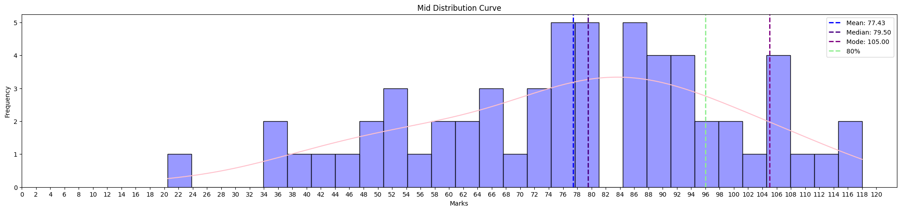

Full Marks

Question |  |  | Topic | Count | Percentage
1 | a |  | Binary to XS-5 Truth Table | 44 | 74.58
 | b |  | K-map Simplification | 6 | 10.17
 | c |  | 2 Level NAND Implementation | 6 | 10.17
 | d |  | Self Complementing Code | 12 | 20.34
2 | a | i | BCD Conversion | 57 | 96.61
 |  | ii | BCD Sum | 16 | 27.12
 |  | iii | Subtraction using 7's Complement | 10 | 16.95
 | b |  | Checksum Integrity | 17 | 28.81
 | c |  | BCD vs Binary Addition | 19 | 32.20
3 | a |  | Tabular Method Simplification | 22 | 37.29
 | b | i | Cut or Try Method Simplification | 22 | 37.29
 |  | ii |  |  | 0.00
 | c |  | Parity | 31 | 52.54
4 | a |  | Lookahead vs Ripple Carry Circuit | 17 | 28.81
 | b |  | Adder Subtractor Circuit | 7 | 11.86
 | c |  | Sequential Circuit | 35 | 59.32

Leaderboard
Leaderboard
Serial | ID | Name | Marks | Percentage
1 | 230042110 | S. M. Samiul Hossain | 118 | 98.33%
2 | 230042141 | Ayman Binta Altaf Nondiny | 115 | 95.83%
3 | 230042152 | Mohammad Faiaj Jarif | 113 | 94.17%
4 | 230042135 | Khadiza Sultana | 109.5 | 91.25%
5 | 230042101 | Mahmudul Hossain Samir | 105 | 87.50%
6 | 230042139 | Sayma Tasnim | 105 | 87.50%
7 | 230042143 | Wasi Omar Syed | 105 | 87.50%
8 | 230042147 | Irfan Sadik Chowdhury | 105 | 87.50%
9 | 230042134 | S. M. Raiyan Al Arafat | 102.5 | 85.42%
10 | 230042120 | Safia Aman Anika | 100.5 | 83.75%

Comebacks
Serial | ID | Name | Mid (%) | Quiz (%) | Improvement (%)
1 | 230042146 | Md Nadid Hassan Khan | 77.50 | 41.25 | 36.25
2 | 230042134 | S. M. Raiyan Al Arafat | 85.42 | 57.5 | 27.92
3 | 230042157 | Md. Shahib-al-kabir | 61.67 | 36.25 | 25.42
4 | 230042141 | Ayman Binta Altaf Nondiny | 95.83 | 72.5 | 23.33
5 | 230042152 | Mohammad Faiaj Jarif | 94.17 | 71.25 | 22.92
6 | 230042137 | Didarul Shahriar | 71.67 | 49.375 | 22.29

Unnecessary Statistics
- 2 student’s handwriting was horrible, barely readable.
- Half of the students did better in mid than quizzes which means you mostly study seriously before mid.
- Quiz Average of top 30 Students are quite good (about 80%).
- Quiz Average increased by 1.12 marks or 5.4% (from 12.24 to 13.32).
- Seventeen students have already achieved passing marks, and some have also earned a grade of C or C+.
- Bonus –
  - If you attended the mid and got above half of total marks (60) → bonus 1 attendance mark.
  - If you attended the mid and got above 75 marks → bonus 2 attendance mark.
  - If you attended the mid and got above 90 marks → bonus 3 attendance mark.
  - If you attended the mid and got above 105 marks → bonus 4 attendance mark.
  - If you achieved the highest marks you got 5 days bonus attendance.

Few Things to be noted
- Read the question carefully.

